Secure VNC
Version 1.0
April 13, 2006
redux.comp.ncat.edu
North Carolina A&T State University
Computer Science Department

Revision Page
Overview:
This document is a description of the Secure VNC program. Included in this document are the Software Project Management Plan (SPMS), Software Requirements Specifications (SRS), Software Design Description (SDD), and System Test Document (STD).
Target Audience:
This document is intended for teachers and students who will be using the software to either access a virtual desktop or providing a virtual desktop to access.
Project Team Members:
The project team members are Daniel Richardson, Designer and Denise Williams, Documenter. The advisor for this program is Ed Carr.
Version Control History:
Version | Primary Author | Description of Version | Date Completed:
1.0 | Denise Williams | Description of project | April 21, 2006

Signatures of Approval:
Team Members: __________________________________________________________
__________________________________________________________
Advisor: ________________________________________________________________

Table of Contents
Software Project Management Plan (SPMS) ------------------------------------ 4
Software Requirement Plan (SRS) ------------------------------------------------ 9
Software Design Description (SDD) -------------------------------------------- 12
System Test Document (STD) --------------------------------------------------- 16
APPENDEX A --------------------------------------------------------------------- 19

Software Project Management Plan (SPMP)
- INTRODUCTION
  - Project Overview
The purpose of this software is to develop a set of administrative tools for the administration of VNC through secure shell. The goal of this software is to provide a secure graphical user-interface for users over the local A&T network. The expected delivery date is Fall 2006.

  - Project Deliverables
The source code, library files, and executable code for the software delivery date is March 24, 2006. A user manual will be included with the distribution of the software. Inside the manual are references you can use if you need to access more information about the product. This user manual delivery date is April 25, 2006. Documentation of the entire software package delivery date is April 25, 2006.

- PROJECT ORGANIZATION
  - Software Process Model
There shall be one review conducted of the software package. Major Milestones to be achieved includes:
1. Securing VNC over an SSH connection
2. Creating an application to disable certain application that students might try to access while connected to the server.
3. Creating a User Manual to be distributed with the software package.
4. Packaging the whole project into an installation file.

There will be one version established for campus wide use. The project deliverables that needs to be completed are the final version of the User Manual and documentation of the software package.

  - Roles and Responsibilities
Daniel Richardson: Responsible for designing and coding Secure VNC project. Denise Williams: Responsible for documenting project and designing user manual for project.

  - Tools and Techniques
For execution of the project we used JAVA to link Plink and VNC server together into one execution.

- PROJECT MANAGEMENT PLAN
  - Tasks
    - Task-1
Name of Task: Schedule – SPMP-T1111
      - Description
This task involved in coming up with a schedule for deadlines for different parts of the project and to come up with times to meet with group members and advisor.

      - Deliverables and Milestones
Milestone 1: Schedule to meet with advisor was completed
Milestone 2: Schedule to meet with team members was completed

      - Resources Needed
None
      - Dependencies and Constraints
Finding times when all of the group members could meet with each other and times when group members can meet with advisor.

      - Risks and Contingencies
None
    - Task 2
Name of Task: Obtaining variables for VNC/SSH Connector - SPMP-T2222
      - Description
This task involved in finding out what variables would be needed in order to use both the VNC and SSH connector together in the same program.

      - Deliverables and Milestones
Milestone 1: Developed Thread structures for VNC/SSH Connector
Milestone 2: Developed the classes in Java needed to execute program

      - Resources Needed
Source code for VNC and SSH.
      - Dependencies and Constraints
Dependency is set on the SSH because if it doesn’t work, when a person logs into the server, it is possible that somebody on the network would be able to access the person’s password because the connection is not secure.

      - Risks and Contingencies
If SSH doesn’t work, personal information could be stolen over the network.
    - Task 3
Name of Task: Disabling certain applications on Linux server-SPMP-T3333
      - Description
This task involved in disabling certain applications on the Linux server while a person is accessing the server, so damage cannot be done to the server.

      - Deliverables and Milestones
Milestone 1: Developing Java Program using ACL list to disable certain applications on Linux sever.
Milestone 2: Developing script file to disable certain applications on Linux server.
Milestone 3: Discovering a way to disable the shut down feature so that users cannot shut down the server.

      - Resources Needed
List of applications on Linux server that needs to be disabled.
      - Dependencies and Constraints
A dependency is a proper list of all applications and features that needs to be disabled.

      - Risk and Contingencies
If this task is not completed, users will be able to access certain applications and features that can potentially do damage to the server or shut it down.

    - Task 4
Name of Task: Developing Executable program-SPMP-T4444
      - Description
This task involved us in finding a way to make the program executable so that people can download it and install it on their own personal computers.

      - Deliverables and Milestones
Milestone 1: Finding a program that turned the executable jar file into an executable file that can be downloaded.

      - Resources Needed
A program that makes executable files and the executable jar file.
      - Dependencies and Constraints
A dependency is we cannot develop an executable file without a completed program. A major constraint is that the executable file being developed can only be used on Windows Operating Systems.

      - Risk and Contingencies
Without finding a way to make the software executable, people will not be able to access the server in a secure manner.

  - Assignments
Task SPMS-T1111- Denise Williams
Task SPMS-T2222- Daniel Richardson
Task SPMS-T3333- Denise Williams and Daniel Richardson
Task SPMS-T4444- Daniel Richardson

  - Timetable
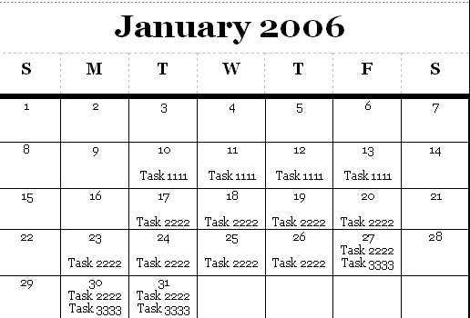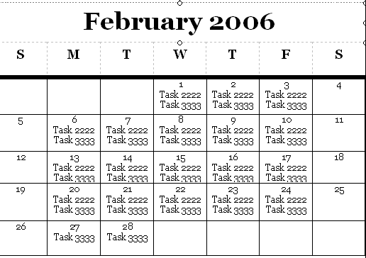
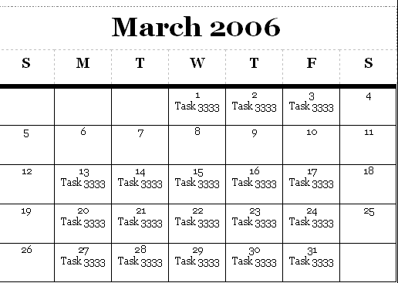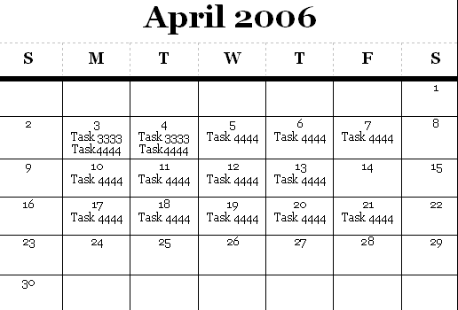
Software Requirements Specifications (SRS)
- INTRODUCTION
  - Product Overview
The purpose of this software is to develop a set of administrative tools for the administration of VNC through secure shell. The goal of this software is to provide a secure graphical user-interface for users over the local A&T network. People who will be using this application are college students, universities, and individuals who needs to view a virtual Linux Desktop over a secure VNC connection. This software can only be used on a computer with a Windows operating system. The system must have Java JRE 5.0 or later also installed. Plink and VNC are included with the software package.

- SPECIFIC REQUIREMENTS
  - External Interface Requirements
    - User Interfaces
      - Login – This dialog box will allow the user to enter its username, password, and the URL or IP that it wants to connect to.

      - Connection – This dialog box will show that it is attempting to make a connection to the server.

      - Error Box – This dialog box will pop up if the program was unable to connect to the server after ninety seconds. If you click on OK, the connection will automatically close.

      - Warning Box – This dialog box will show up to authenticate the host key.

    - Software Interfaces
      - Windows 98/NT/2000/XP – These are the operating systems that will allow the software to run properly because the software is an executable file.

      - Java JRE 5.0 or later – This will allow the software interface to appear on the screen.

    - Communications Protocols
You must have the name of URL and an account with the Linux machine you are accessing. Also port 22 and ports 5900-5999 must be accessible via the internet.

  - Software Product Features
    - Login – ESSENTIAL
The system shall ask the user for its URL or IP Address, username, and password. After user enters information, user will click on start connection to transfer control to the Plink Connection.

    - Plink Connection - ESSENTIAL
The system shall create a Plink connection to server, using the username, password, and server name provided by the user. You would click submit on the main dialog page after you type in the before mentioned requirements. The dialog will then switch to connection dialog stating “Connecting… please wait”

    - SSH Tunneling Connection – ESSENTIAL
The system shall secure the connection between the client computer and the server you are accessing. After the user clicks Start Connection, a dialog box will appear saying “Connecting please wait”.

    - VNCServer Connection – ESSENTIAL
The system shall start VNC connection by firing the VNC application utilizing the local host at port 5900, which is tunneled through the SSH Connection.

    - ERROR Login – ESSENTIAL
The system shall verify if your connection string, username, and password is valid. If any of the entries are not valid, the following error message will appear: “Error Connecting please check your connection string, username and password”

  - Software System Attributes
    - Reliability
The software should be useable up to one year, which at that time, VNC or SSH, or both should be updated possibly causing some software failure.

    - Availability
Being that this program is a downloadable executable file, any time that you need to use the program, you can go to the website and download it.

    - Security
The reason for designing this software is to maintain security between the user and Linux server. Passwords sent across the network are encrypted. The database containing all the user names and passwords are stored in a secured location. Applications on the Linux server are disabled so that users will not be able to do anything malicious against the Linux server.

    - Maintainability
The software is written in class form, so that it is readable and updatable.
    - Portability
This software is usable on any computer that is using a Windows operating system and has Java JRE 5.0 or later installed on it.

    - Performance
Only one user is allowed to use the software at one time, but multiple users may access the Linux server at the same time.

Software Design Description (SDD)
- INTRODUCTION
  - Design Overview
The design approach was to take the physical process of making the connection over SSH tunnel and separate the components into separate classes to where each class controls it specific part of making the connection work. Each class has its own functions to handle different parts of a connection such as errors, input/output, and message handling.

  - Requirements Traceability Matrix
 | Login | Plink Connection | SSH Tunnel | VNCSever Connection | Error Login
JRE | X | X | X | X | X
Network Connection |  | X | X | X
URL or IP |  | X | X
User Name |  | X | X
Password |  | X | X

- SYSTEM ARCHITECTURAL DESIGN
  - Chosen System Architecture
We decided to use Java to implement the design of combining the SSH and VNC server to create a secure virtual network connection.

  - Discussion of Alternative Designs
We first discussed using Pam-Aware to create a secure connection. Pluggable authentication models (PAM) allows a person to configure a Linux environment with the level of security you deem necessary. Reason for not using is because learning curve was extensive and implementation would have not allow the project to be done on time.

  - System Interface Description
Windows – This is the operating system that users will be using to access the Linux server and downloading the Secure VNC program.
SSH – This is the process to authenticate the user accessing the VNC and creating a secure connection between the user computer and the virtual desktop they are accessing.

Plink – This is a command-line interface to the SSH.
JRE 5.0 – This is the GUI interface between the user and the program. It will display the Login screen for the user to enter the URL, username, and password.

Linux – This is the server that the user will be accessing.
- DETAILED DESCRIPTION OF COMPONENTS
  - Component – 1: Login
Login is responsible for asking the user for their URL or IP address, username, and password. It requires only the JRE because it is the JRE that allows the Login screen to appear.

  - Component – 2: Plink Connection
Plink Connection is responsible for creating a connection between the Linux server and Windows machine. It is also responsible for firing the VNCserver on the Linux server, getting the port that the VNCserver is fired from, and closing the SSH connection after it is finished. The constraints are it must have a network connection, username, password, and URL for the Linux server it is trying to access. Plink interacts with the Linux server and Windows machine.

  - Component – 3: SSH Tunnel
SSH Tunnel is responsible for making the final SSH connection utilizing port forwarding. The constraints are it must have a network connection, username, password, and URL for the Linux server it is trying to access. After connecting to the Linux server, the SSH Tunnel transfers control to the VNCserver connection.

  - Component – 4 VNCserver Connection
VNCserver Connection is responsible for starting the VNC Client Software on the local port 5900. The only constraint is that the Network Connection is made with port 5900 tunneled to a port on the Linux Server.

  - Component – 5 ERROR Login
The Error Login is responsible for letting the user know that the connection failed do to improper login data or it possible could be that the network connection was never established. This just requires that the JRE is installed.

- USER INTERFACE DESIGN
  - Description of the User Interface
    - Screen Images
These are the different screen shots you will and might encounter when you operated the program.

Screen 1: 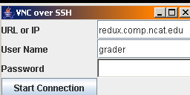 Screen 2: 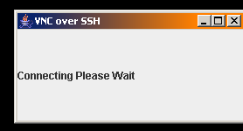
Screen 3: 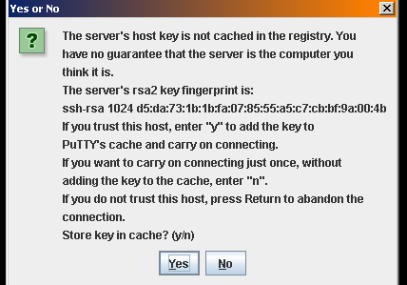 Screen 4: 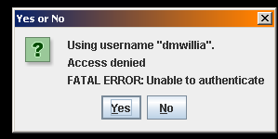
Screen 5: 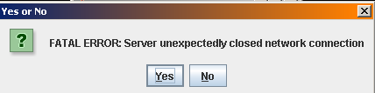 Screen 6: 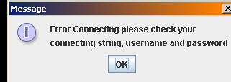
    - Objects and Actions
For Screen 1:
The fields are places where you will enter the URL, the username, and password. The start connection button will attempt to connect you to the server.

For Screen 2:
This displays that the application is trying to connect to the server.
For Screen 3:
This displays whether you trust the connection that you are trying to access. If you click “Yes”, your Key will be added to the cache and connection to the server will continue. If you click on “No”, your key will not be stored into the cache and connection to the server will continue.

For Screen 4:
This displays that the username is not recognized and that you do not have authorization in accessing the server. When you click on yes or no, another screen will appear.

For Screen 5:
This displays that it was an error trying to connect to the server. After this screen, another screen will appear.

For Screen 6:
This screen displays that there was a problem with either your URL, username, or password. When you click on OK, the connection will end.
System Test Document (STD)
- INTRODUCTION
  - System Overview
Most of the testing will consist of making sure that connections are working properly such as the Plink and SSH. Additional testing will include logging in and installation of the program.

  - Test Approach
With the Plink connection, we will test to see if we receive errors if you input bad data and not receive errors when you enter good data. With the SSH tunnel, we will test to see if we receive errors if you input bad data and not receive errors when you enter good data. With login, we will test to make sure that the URL, username, and password is valid. With the program, we will test to see if it will install properly without errors.

- TEST PLAN
Daniel Richardson will be responsible for testing each aspect of the program. These aspects include: Login, Plink Connection, SSH Tunnel, and installation of the software on Windows operating systems.

  - Features to be Tested
There will be four features tested: Plink Connection, SSH Tunnel, Login, and the actual software installation.

  - Features not to be Tested
VNCServer will not be tested because we implemented the actual VNCSever into the program and we know that VNCServer works.

  - Testing Tools and Environment
A requirement of the test environment includes a computer with a Windows operating system and JRE 5.0 installed on it. Testing should take about a week to complete.

- TEST CASES
  - TC – 1111
    - Purpose
This is to test the Plink connection as referred to in SRS section 2.2.2. This will test whether it will fire the VNCServer or not.

    - Inputs
Inputs will include all the information from the login screen which is URL, username, and password.

    - Expected Outputs & Pass/Fail criteria
If the user has entered the appropriate the URL, username, and password, it should connect to the Linux server. If any of these is incorrect, an error message should appear stating “Error connecting please check your connection string, username, and password”

    - Test Procedure
A user enters in their URL, username, and password. The user then presses “Start Connection”

  - TC – 2222
    - Purpose
This will test the SSH Tunnel as referred to in SRS section 2.2.3. This will test if the connection is secured between the user computer and server and to see if it will transfer control to the VNCServer.

    - Inputs
Inputs will include all the information from the login screen which is URL, username, and password.

    - Expected Outputs & Pass/Fail criteria
If the user has entered the appropriate the URL, username, and password, it should connect to the Linux server. If something is wrong with the connection, an error message shall appear saying “Server unexpectedly closed network connection”.

    - Test Procedure
A user enters in their URL, username, and password. The user then presses “Start Connection”

  - TC – 3333
    - Purpose
This will test the login as referred to in SRS section 2.2.1. This will test the input entered into its fields as valid or invalid.

    - Inputs
Inputs will include the URL, username, and password.
    - Expected Outputs & Pass/Fail criteria
If each of the fields is correct, then the next thing that will happen is the execution of Plink firing up the VNCServer connecting the user to the server. If any of the input is incorrect or missing, an error message should appear stating “Error connecting please check your connection string, username, and password”.

    - Test Procedure
A user enters in their URL, username, and password. The user then presses “Start Connection”

  - TC - 4444
    - Purpose
This will test the installation of the software onto a computer.
    - Inputs
When installing, there is an option whether you want the install for the user personally or for all users. You also have an option whether you want to change the folder of where you want the files installed and if you want shortcuts on your desktop and start menu.

    - Expected Outputs & Pass/Fail criteria
If installation is run correctly, there should be a message appearing that the installation was completed successfully.

    - Test Procedure
Go to the download page and save the .exe to the desktop or run it from the web page. Double click on the .exe file to start installation.

APPENDEX A. TEST LOGS
A.1 Log for TL – 1111
A.1.1 Test Results
For each execution, record the date/time and observed results (e.g., error messages generated). Also record the location of any output (e.g., window on the screen). Record the successful or unsuccessful execution of the test.

A.1.2 Incident Report for TIR – 1111
If the test failed, or passed with some unusual event, fill in this incident report with the details. Summarize the incident, identifying the test items involved, and the anomaly in the results. Indicate what impact this incident will have on the project.

A.2 Log for TL – 22222
A.2.1 Test Results
A.2.2 Incident Report for TIR – 2222
A.3 Log for TL – 3333
A.3.1 Test Results
A.3.2 Incident Report for TIR – 3333
A.4 Log for TL – 4444
A.4.1 Test Results
A.4.2 Incident Report for TIR – 4444

